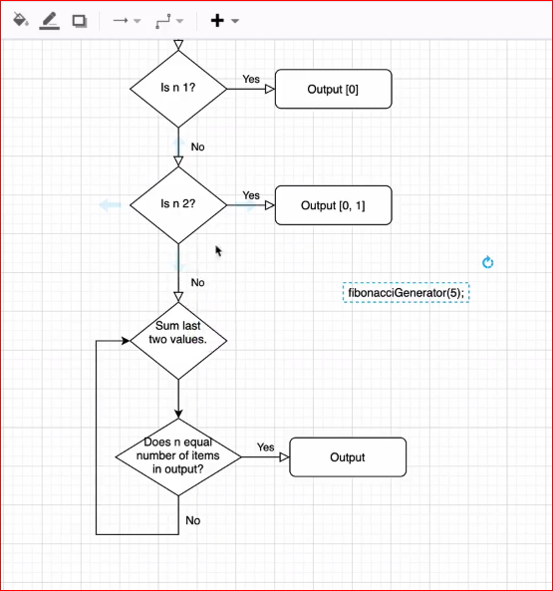

function fibonacciGenerator (n) {

//Do NOT change any of the code above 👆

//Write your code here:

var f = [];

if (n === 1) {

f.push(0);

return f;

} else if (n === 2) {

f.push(0);

f.push(1);

return f;

} else {

var a = 0;

var b = 1;

var c = 0;

f.push(a);

f.push(b);

for(i=2; i<n; i++) {

c = a + b;

f.push(c);

a = b;

b = c;

}

return f;

}

//Return an array of fibonacci numbers starting from 0.

//Do NOT change any of the code below 👇

}